Lab 02 Spatial Partitioning

**Fufillment**

* I finished all the objectives!

**Execution**

* I do not believe there should be any unexpected requirements for running

**Controls**

* Pressing the X key will close the application
* Pressing the P key will pause the application, pressing it again will un-pause the application
* Pressing numpad 0 will re-read the config file
* Pressing M, L, T or C will dump engine info to the console, this is pretty much exclusively used for debugging
  + C logs the relevant spatial partitioning information
* Pressing W will rotate BetterDargon to the left, S will rotate him to the right
* Pressing A will tilt BetterDargon forward, D backward
* Pressing Q will roll BetterDargon to the left, E to the right
* Holding space will move BetterDargon forward, in the direction he is facing, releasing will halt movement
* Right clicking and dragging the mouse will turn the camera around BetterDargon
* Scrolling in or out with the mouse wheel should zoom the camera accordingly, up to a minimum or maximum distance
* Pressing (non-numpad) 6 will increase BetterDargon’s speed, multiplicatively, up to a maximum
* Pressing (non-numpad) 7 will decrease BetterDargon’s speed, multiplicatively, down to a minimum
* Pressing (non-numpad) 8 will toggle the flag raycasting on or off completely, including the display of debug rays
* Pressing (non-numpad) 0 will set all objects in the STATIC_GEOMETRY layer to on, and the rest to off, both for purposes of raycasting and viewing
* Pressing (non-numpad) 1-4 will set all objects in THE RESPECTIVE LAYER (1-4) to on, and the rest to off, both for purposes of raycasting and viewing
* Pressing (non-numpad) 5 will set all objects in ALL LAYERS layer to on, and the rest to off, both for purposes of raycasting and viewing
* Clicking a fractal sphere will move it 100 units away and change its color, if it leaves the grid it will spontaneously cease to exist (on purpose), being completely removed from the rendering and collision linked lists as we never intend to process it again for the duration of the application
  + You will notice framerate increases as we remove fractal spheres
    - I’d add a particle effect for exploding or something, but time constraints and irrelevance

**Screenshots**

* **Spatial Partitioning**
  + **The first screenshot shows casting five rays every frame against tons of objects to see if the flag is hit, you can see the rays going from the player character to the flag. The background color is yellow to indicate that BetterDargon can see the flag. Notice still 62 fps in debug mode!**
  + 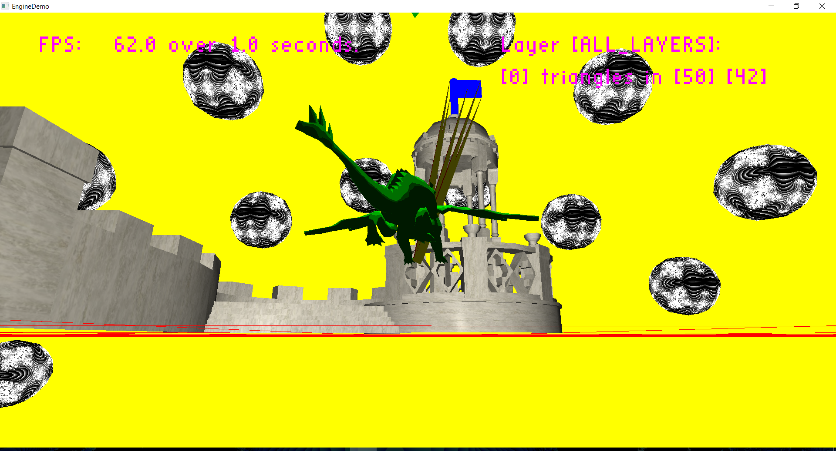
  + **The second screenshot shows a case in which BetterDargon cannot see the flag because it is obstructed. The background color is black to show that he could not see the flag.**
  + 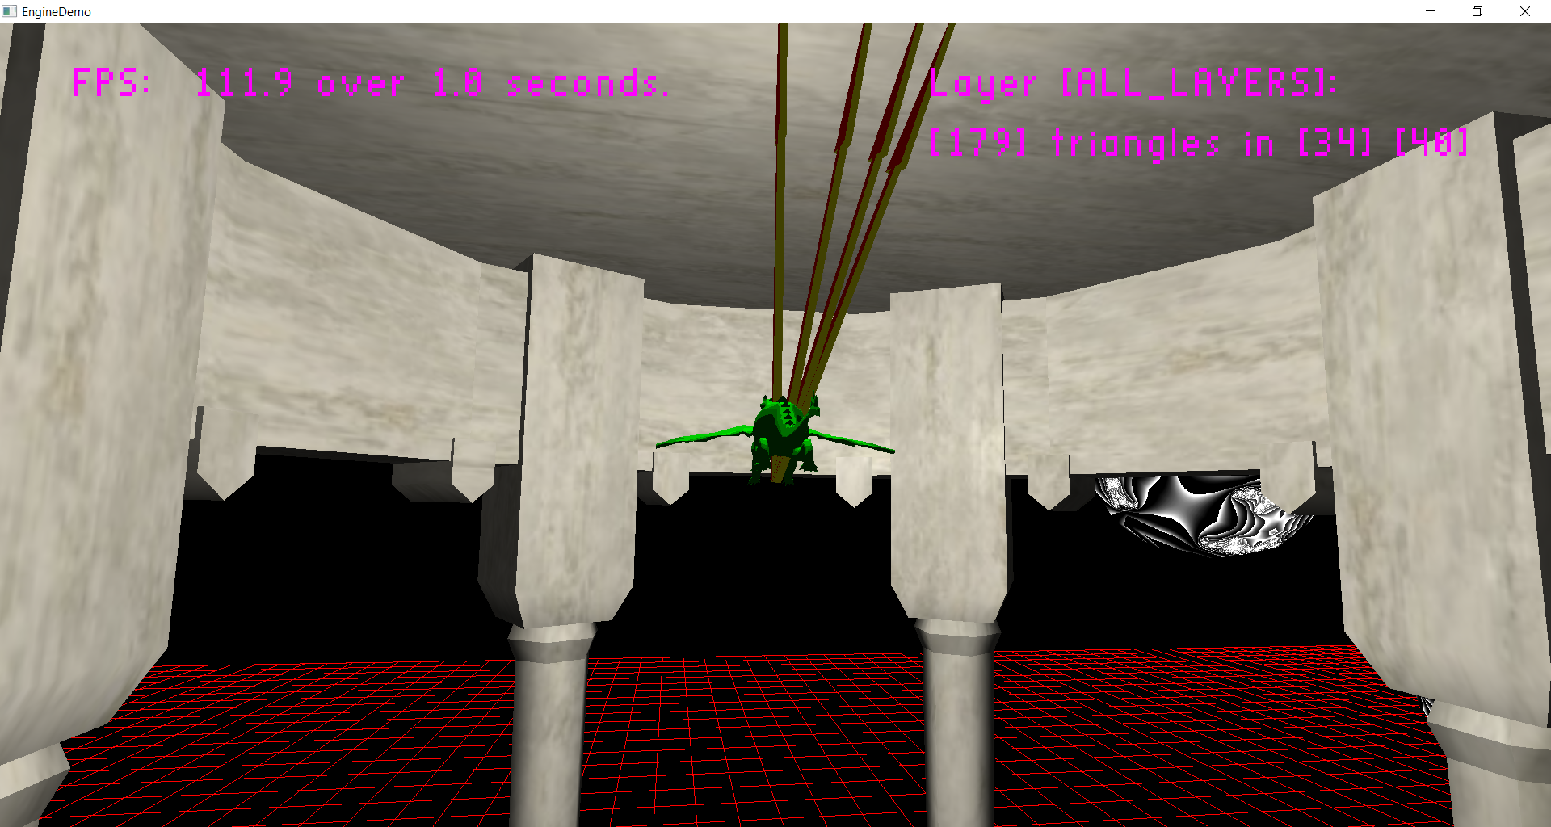
  + **This screenshot shows tons. The fractal sphere is in a different layer, so it shows that I can raycast against all layers, as I am doing for the flag, and the rays stop when they are hit, which I thought was a useful feature, also, the fractal sphere has culling disabled, and I added support for colliding against both sides of triangles for objects with culling disabled (if you can see both sides of a triangle, you’d expect to be able to interact with both sides of the triangle!) Here we are interacting with the inside of a fractal sphere.**
  + 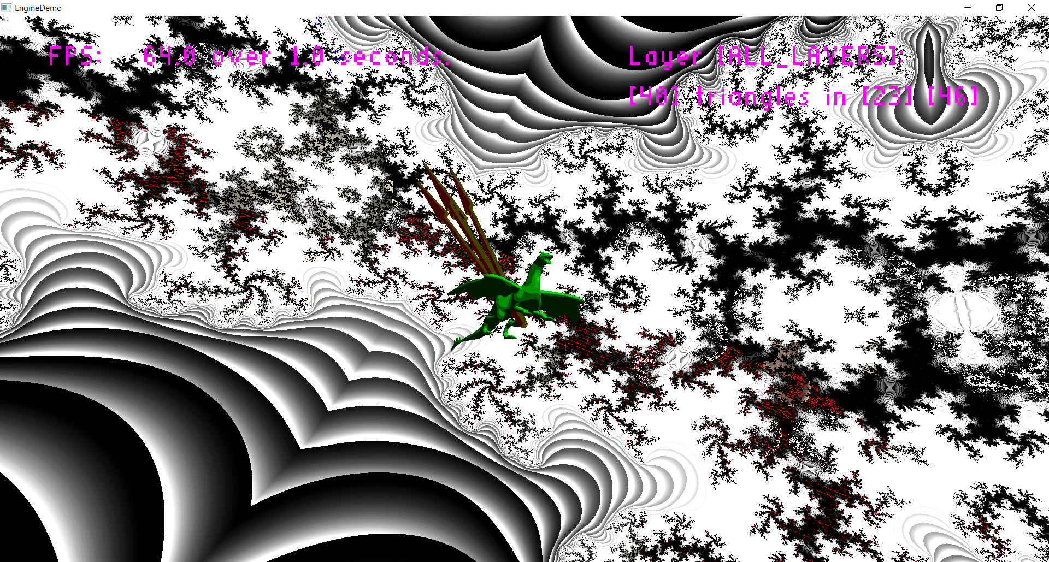
  + **Here, to prove my two-sided raycasting for culling-disabled objects, we have the player raycasting and hitting the other side of the triangles for the same sphere.**
  + 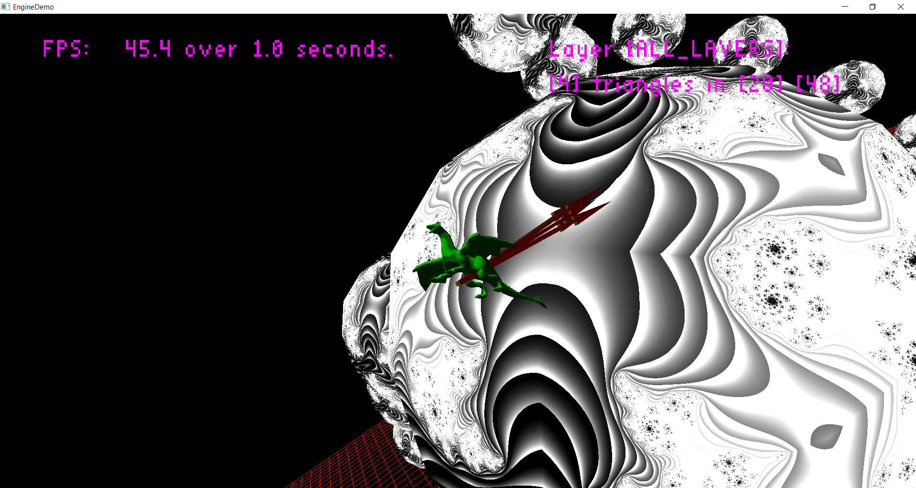
  + **Here is another screenshot indicating flag visibility with raycasts against the flag. When not by a high-poly object (dargon), this is about as low as the fps gets (45).**
  + 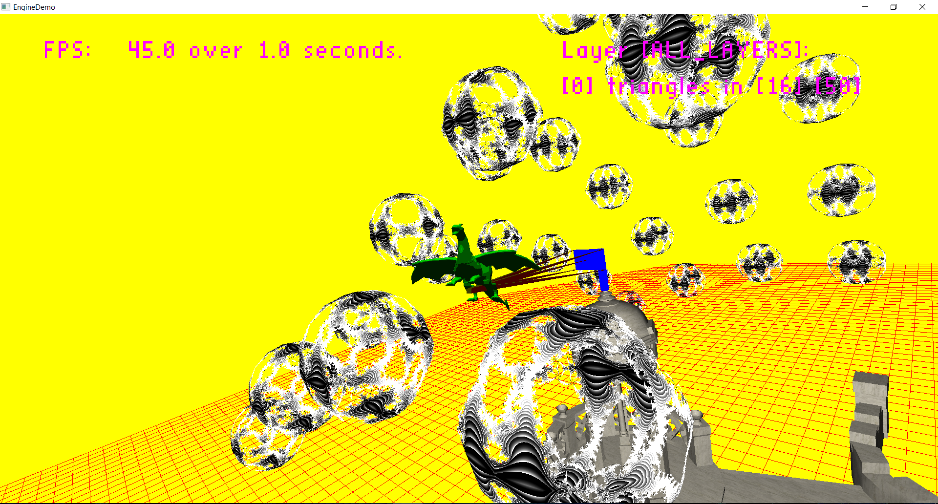
  + **Here we demonstrate querying the grid for how many triangles are in a layer, as you can see, across all layers, there are 22 triangles in this cell.**
  + 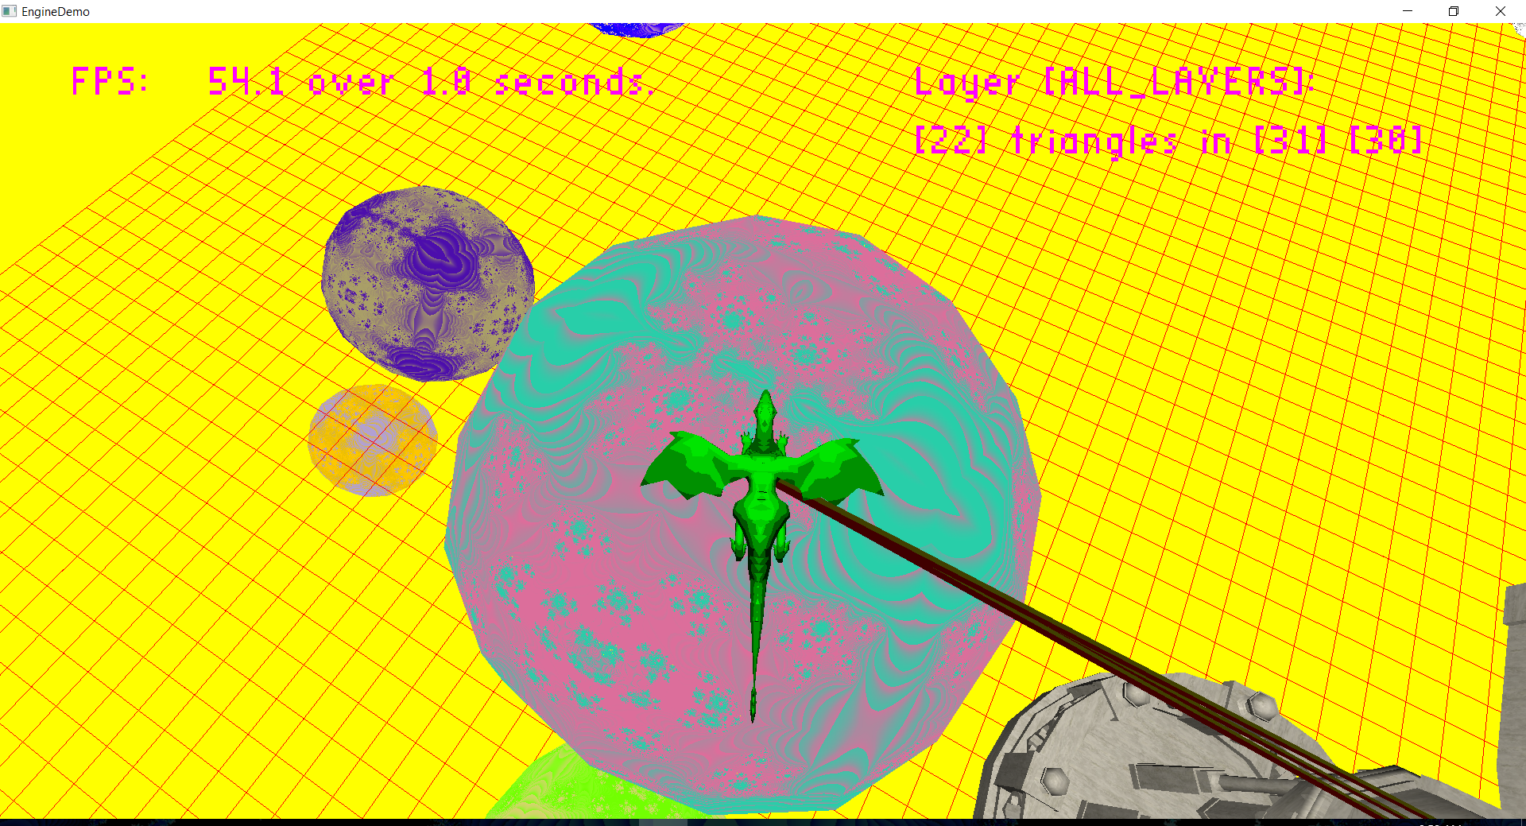
  + **Here we begin demonstrating multiple layers, the spheres in this cell belong to different spatial grid layers. Across all layers, there are 60 triangles in this cell.**
  + 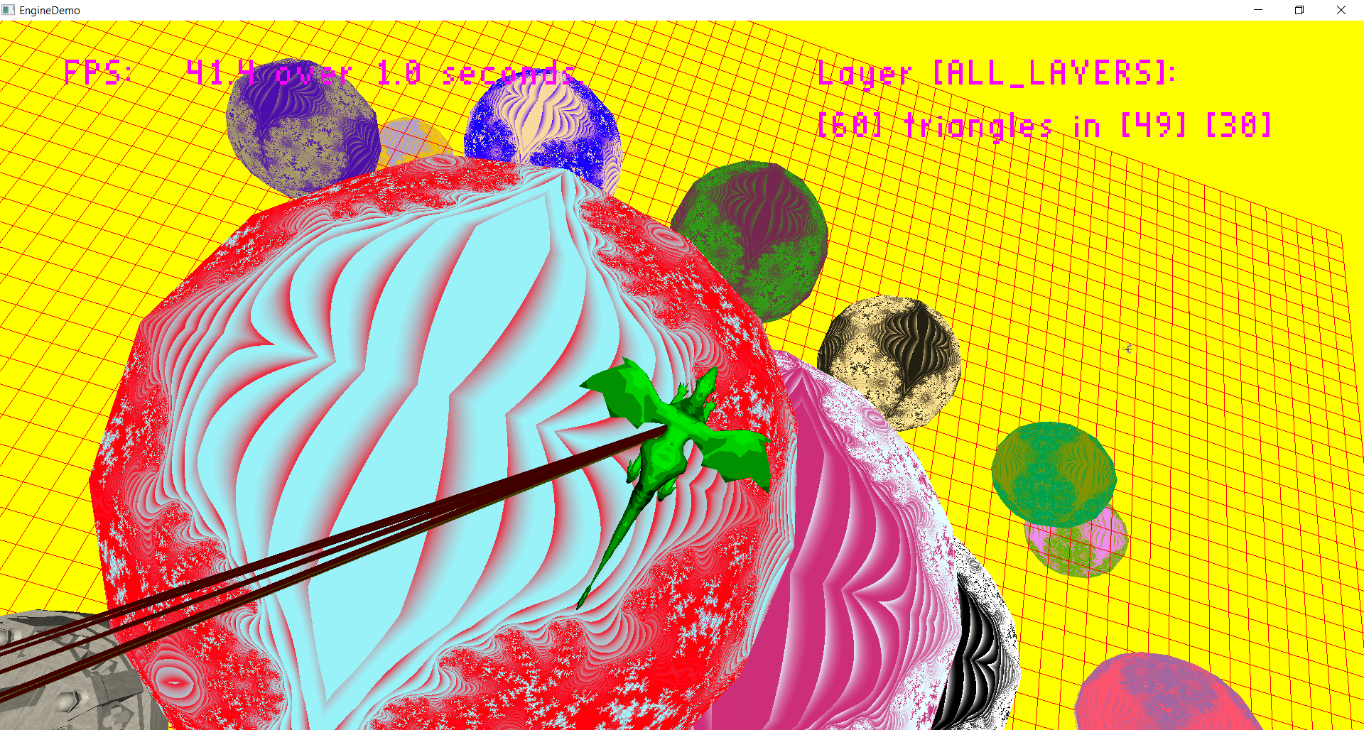
  + **On the other hand, in the same cell, we can see there are only 40 triangles in layer 3. This is very cool because, lets say, hypothetically, we only cared about raycasting against the layer 3 triangles, we would have to check less triangles, making raycasting faster. Also, if we need to recalculate some object positions, we only need to recalculate one layer, which is much faster than recalculating all the grids!**
  + 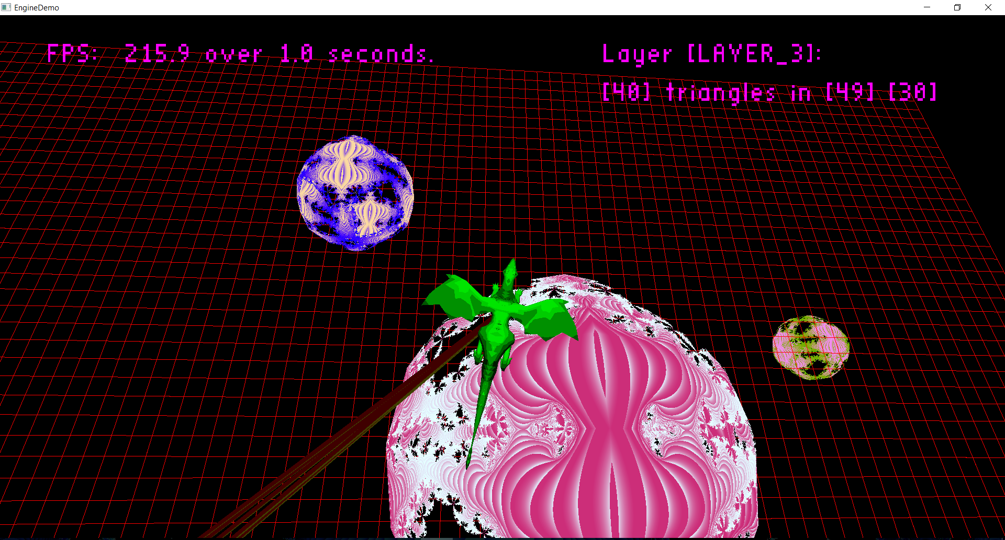
  + **Shows that, again in the same cell, there are 20 triangles in layer 2. Note that the other layers are empty in this cell and 20 in layer 2 + 40 in layer 3 = 60 total as is displayed.**
  + 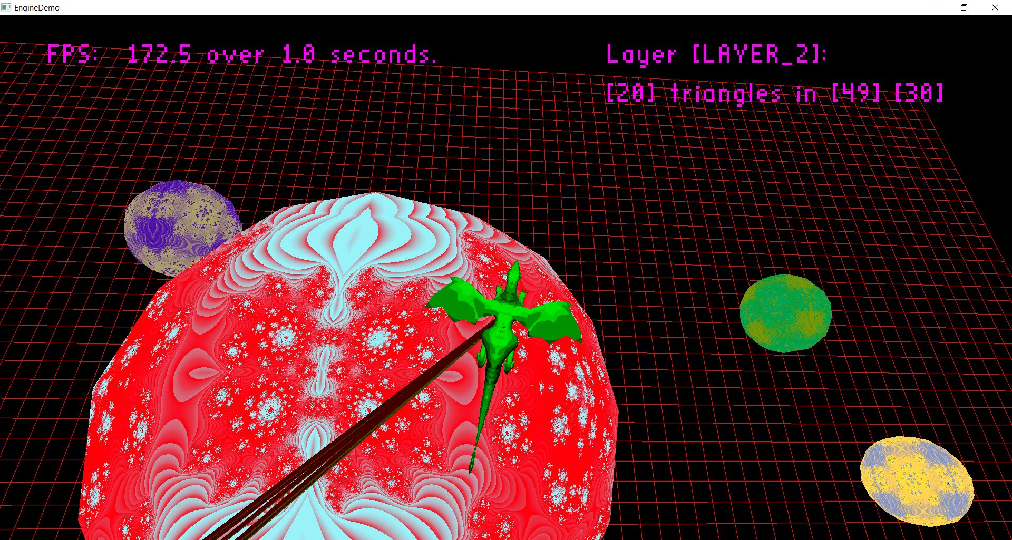
  + **Shows the required high poly object in a single cell. That’s a lot of triangles! Note that I had to disable all five per-frame raycasts to go into this cell without fps dropping below 1. He’s just too high poly to collide against. (actually in release I get 20 fps in this cell…)**
  + 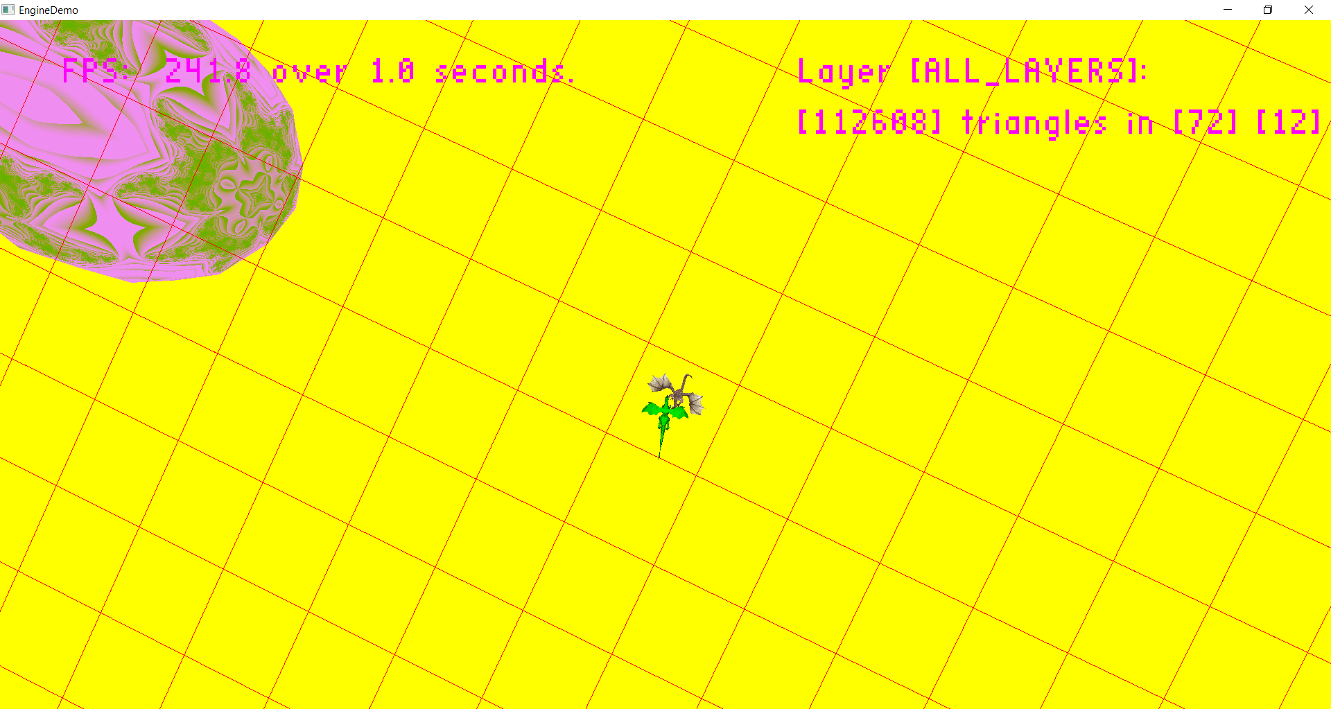
  + **Another high poly object, this time, spread over multiple cells. Again, super high poly, and expensive to raycast against (though much less so in release mode…)**
  + 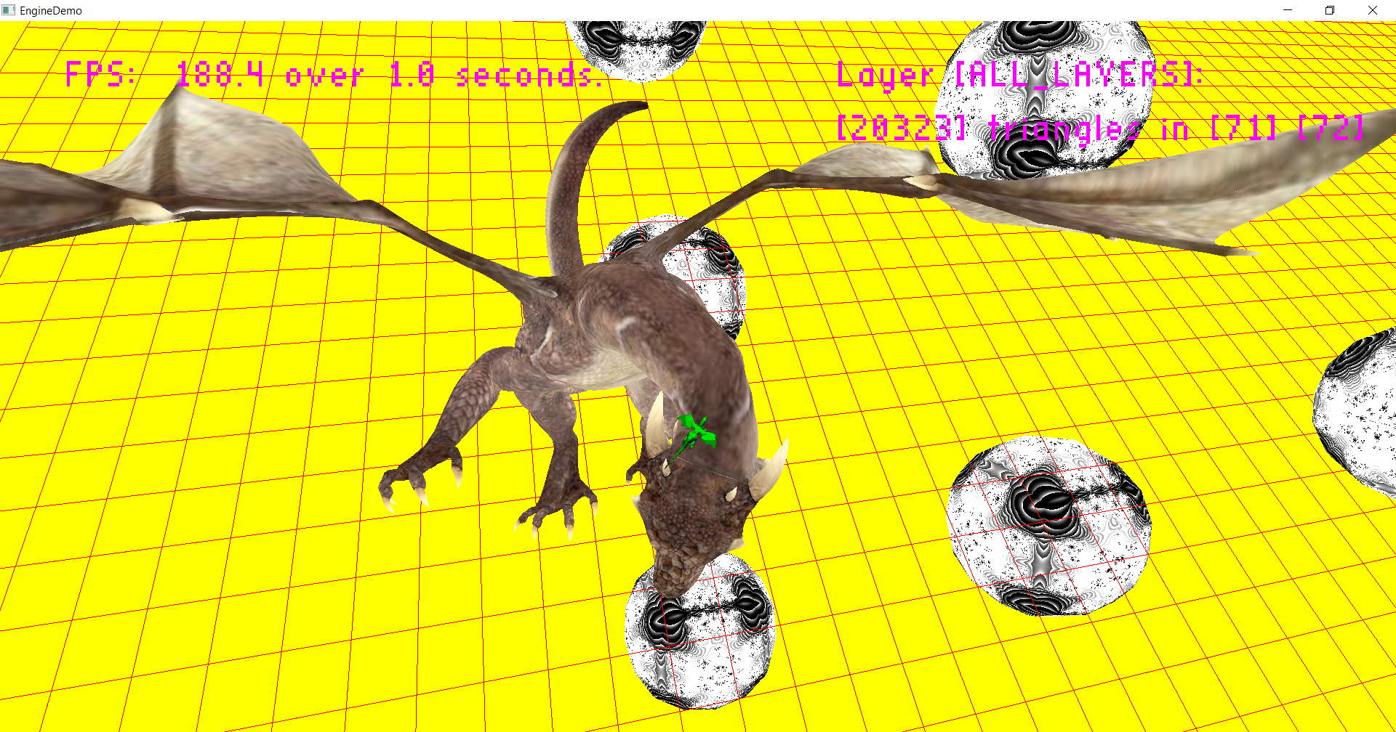
  + **Shows only the static geometry for this scene, I thought it might be useful to see/reference**
  + 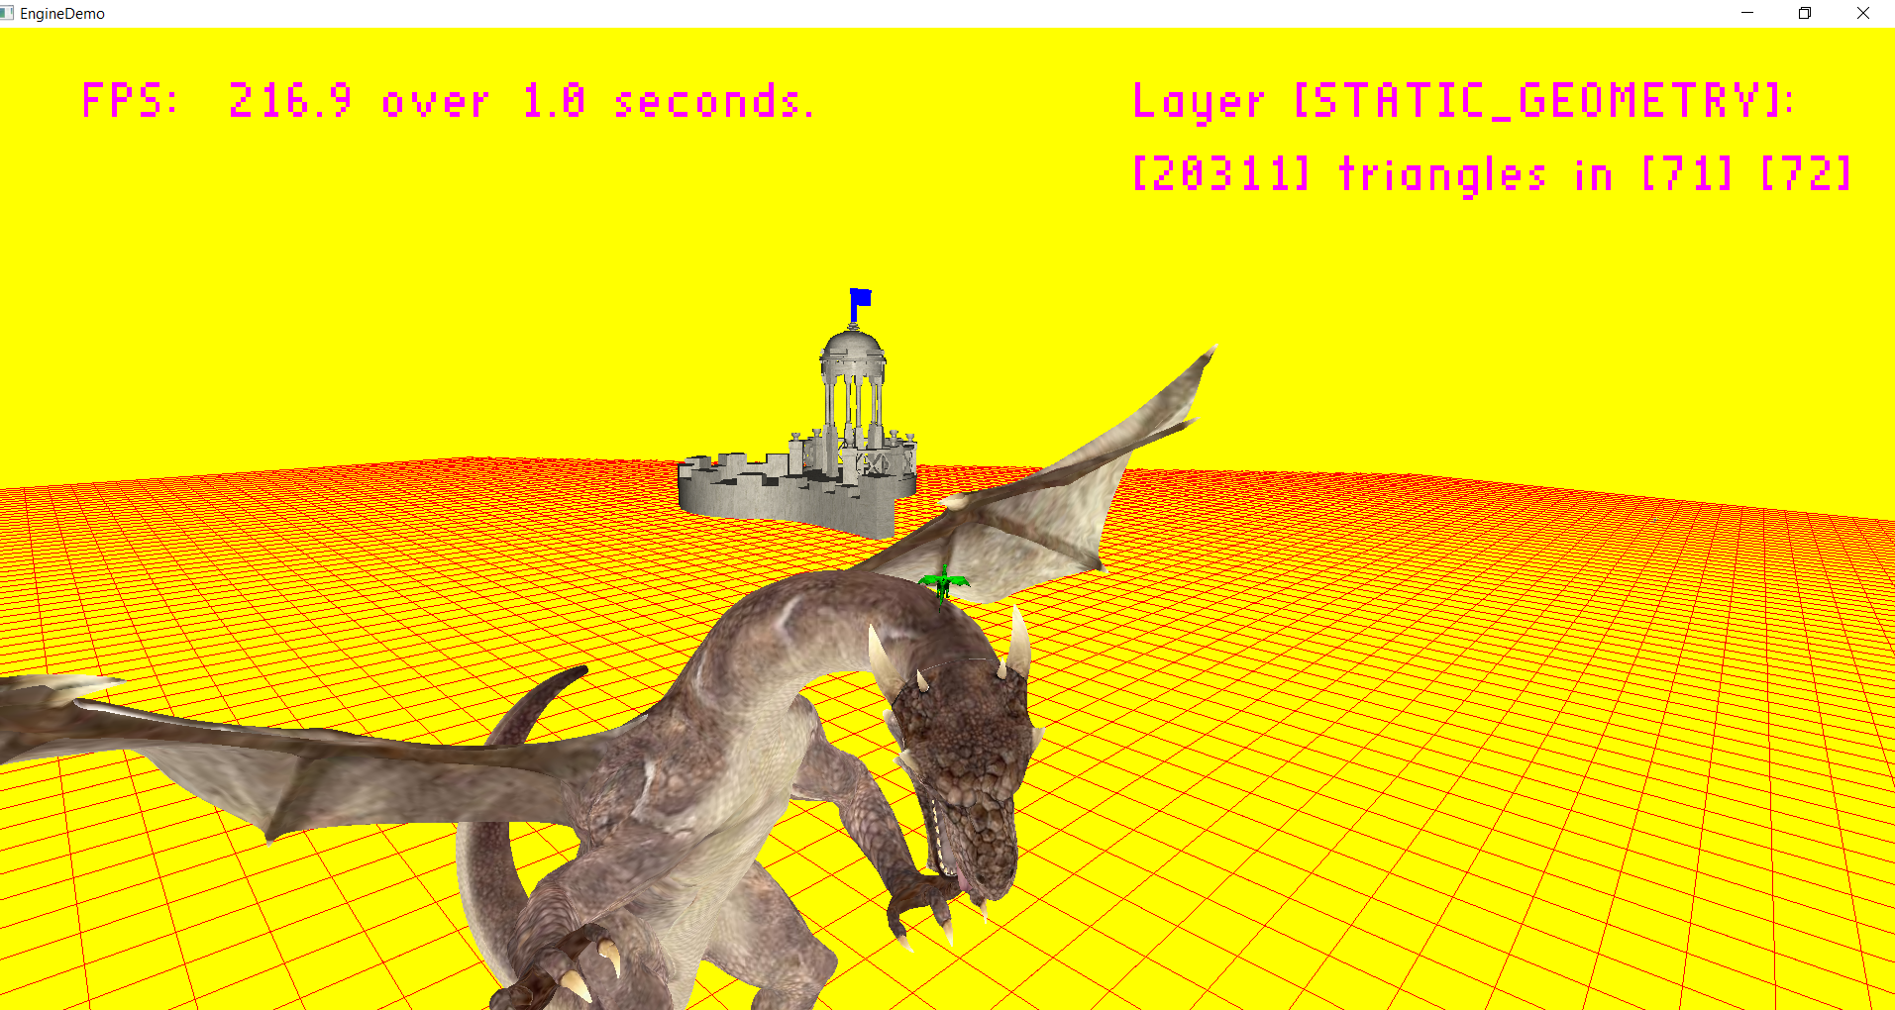
  + **Shows console output for a scene with few spheres moved, note different layers have different statistics!**
  + 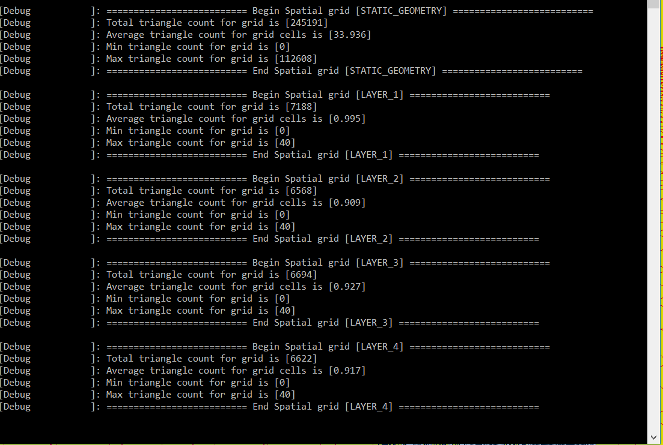
  + **Shows a scene with about half the fractal spheres clicked into oblivion and the other half slightly moved. Reference for next stats screenshot.**
  + 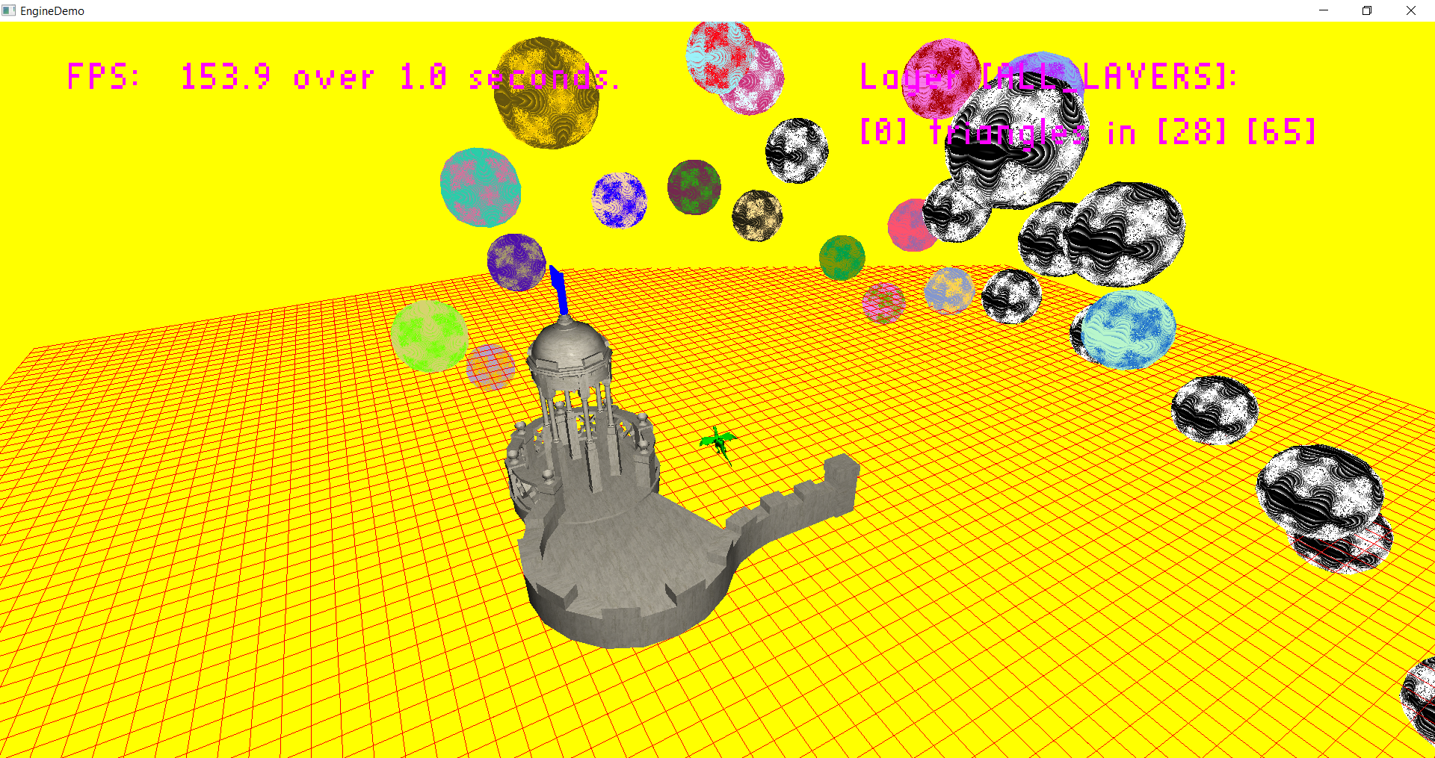
  + **Note that the stats change as we re-calculate post object destruction.**
  + 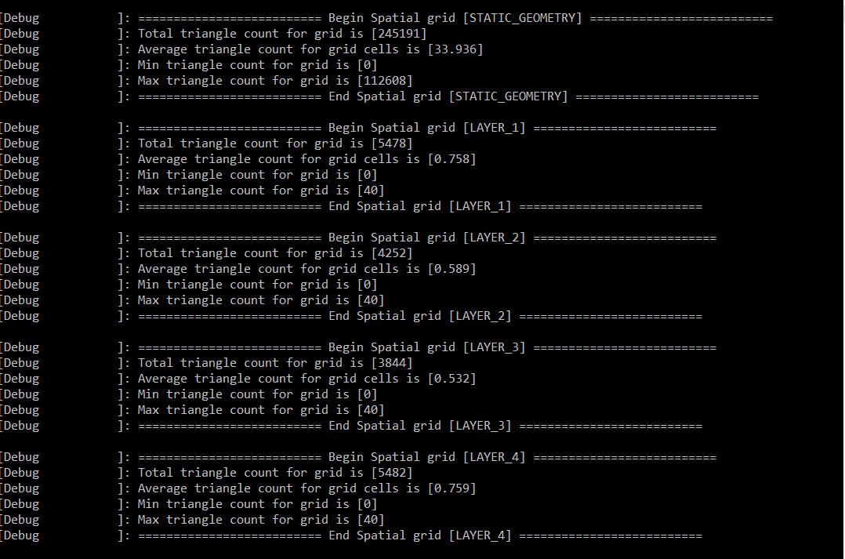

**Post-Mortem**

* This lab was pretty large…
  + 
  + **\*COUGH* LOG FILES *COUGH\***
  + I spent pretty much all weekend on it, **definitely over 10 hours** – and I already had a 2D grid! I just had to debug it, refactor it, expand it to support multiple layers and do the demo!
* I ran into tons of issues but I fixed them all
  + I had an off by one error in my spatial partitioning that has been hiding since 4th quarter… I finally resolved it…
  + My sky sphere models had 3900 invisible verts, causing unnecessary lag…
  + Tons of small stuff
  + My text was done awfully, and it still kind-of is, but at least the worst part is fixed
    - I saw that I was sending the text data every time I drew it, (leftover bad code from fourth quarter) and face-palmed so hard…
      * You know you’ve grown to be a better programmer when you see code you wrote and you are ashamed and re-write it way better
        + Before this fix, I was limited to two text objects, now I can do three with zero issues (four+ not yet tested, but I assume its fine with the fix)
* Refactoring
  + I got to remove some duplicate code from my spatial partitioning and render engine, finally
  + I store the triangle data in world space in my triangle data struct so I am no longer recalculating it every time we raycast against it
    - Made the difference between 30 and 45 fps in the test scene (debug mode) ☺, but takes more memory space for my grid… worth it?
  + I used instancing for my grid ☺
  + I made a more robust generic linked list class so I’m not writing loops to manually iterate over an objects next nodes everywhere… definitely makes some parts of my engine more readable/cleaner/less duplicate code
  + Also wrote some utility methods for iterating over the verts in a triangle, again just kinda removes duplicate code
* I’d love to upgrade it to a 3D grid, but I’d need to sit down and do some math
  + I know I’d only really need to change my grid class and how I iterate between grid cells in FindWall… but I just didn’t have the time to rewrite that part in addition to the layers, debugging, and refactoring I accomplished
* It is actually noticeably better…
  + Re-calculating is so much faster, I can actually have moving objects that I raycast against now, fps is noticeably higher
  + Again, I’m certain I can now do things in my engine I was not capable of before, so long as I actually use the different layers instead of shoving everything in the static layer ☺
* Post-Post Morten
  + **I spent an additional 2-3 hours upgrading my grid to 3D**
    - **It was not as difficult as I expected, because my code was decently re-factored and the algorithms for traversal and dividing into grid sections are quite similar**
    - **In most cases, debug mode, with 5 raycasts per frame in my demo scene, there was between a 1.8 and 2.1 times increase in fps**
      * **Like 40 to 90 (across most of the scene)**
      * **3 to 8 (very high poly cells)**
      * **80 to 150 (right in my gazebo)**
    - **The one downside is that it takes longer to calculate the grid, but I think that the fps increase is worth this extra second of load time.**